Lesson 4 Demo 6
Switching Branches in Git

Objective: To switch between branches in Git

Tools required: Git

Steps to be followed:
- Create a new branch
- Switch to the new branch
- Create a file and commit the changes
- Check the status of the new branch
- Switch back to the main branch
Note: A projectfile is already created in Demo 5. If you do not have a repository, first perform that demo and then execute the steps from this demo.
Step 1: Create a new branch
1.1 Open the Terminal in your lab, and navigate to the projectfile folder
cd projectfile
1.2 Execute the following command to create a new branch:
git branch text_branch

Step 2: Switch to the new branch
2.1 Use the following command to switch to the newly created text_branch:
git checkout text_branch
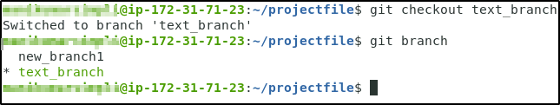

Step 3: Create a file and commit the changes
3.1 Use the following command to create a file:
vi index.html
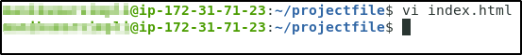
3.2 Add the following code snippet in the index.html file
<html>
<body>
<p> This is a Test HTML file. </p>
</body>
</html>
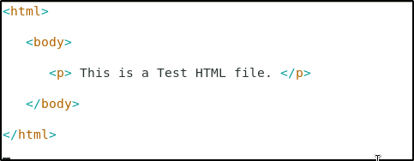
Note: Press Esc button and enter :wq to save the file.

3.3 Use the following commands to add the file to the text_branch, and commit the changes:
git add index.html
git commit -a -m "file modified"
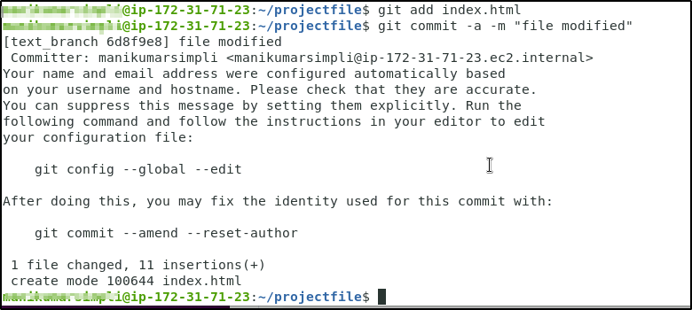

Step 4: Check the status of the new branch
4.1 Check the status of the new branch using the following command:
git status
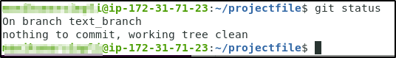

Step 5: Switch back to the main branch
5.1 Check the current branch using the following command:
git branch
5.2 Use the following command to switch back to the main branch:
git checkout new_branch1
